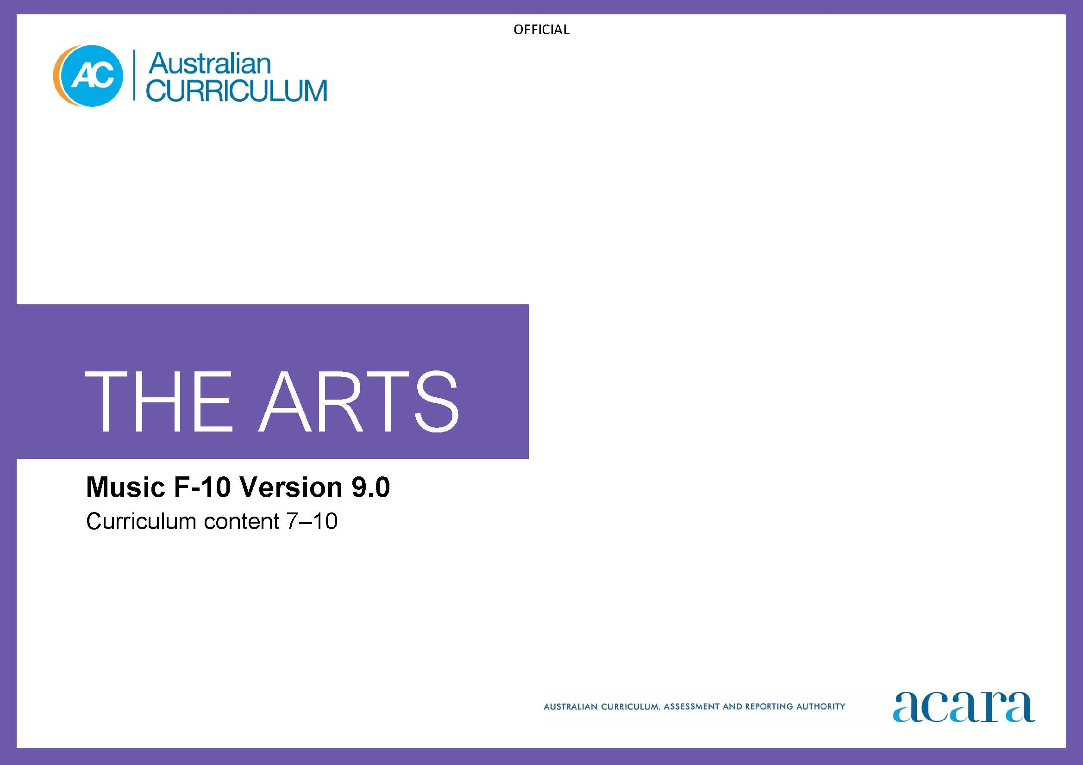

Copyright and Terms of Use Statement
© Australian Curriculum, Assessment and Reporting Authority 2022
The material published in this work is subject to copyright pursuant to the Copyright Act 1968 (Cth) and is owned by the Australian Curriculum, Assessment and Reporting Authority (ACARA) (except to the extent that copyright is held by another party, as indicated).
The viewing, downloading, displaying, printing, reproducing (such as by making photocopies) and distributing of these materials is permitted only to the extent permitted by, and is subject to the conditions imposed by, the terms and conditions of using the ACARA website (see, especially, clauses 2, 3 and 4 of those terms and conditions). The terms and conditions can be viewed at https://www.acara.edu.au/contact-us/copyright

TABLE OF CONTENTS
Curriculum elements 3
Years 7–8 3
Years 9–10 9

Curriculum elements

Years 7–8
Band level description
In this band, learning in Music builds on each student’s prior learning and experiences. Students learn in and through the music practices of listening, composing and performing. They use their music knowledge and skills in purposeful and creative ways, and continue to develop their connection with and contribution to the world as composers and performers and as audiences. They work individually and in collaboration with peers and teachers.
Students explore music in local, regional, national and global contexts such as music used in multi-arts, trans-disciplinary or hybrid forms, or music from countries or regions of Asia. They take opportunities to engage with living composers and performers, and expand their awareness of the diversity of music practices, genres and/or styles.
In this band, the focus is on students:
- exploring and responding to
  - music and music practices across cultures, times, places and/or other contexts; for example, through listening and evaluating their own music practices or analysing performances and compositions created or presented by others
  - the diversity of music created by First Nations Australians and how this work demonstrates respect for Indigenous Cultural and Intellectual Property rights
- developing practices and skills
  - creative practices and skills for listening (including aural skills), vocal and instrumental performance, and composition in music genres and/or styles of interest, interpreting and manipulating the elements of music: duration/time (including beat and rhythm, tempo, pulse, simple/compound metre), pitch, dynamics and expression, form and structure, timbre and texture
  - critical practices for reflecting, analysing, evaluating and responding to their own work and the work of others; for example, considering how to apply knowledge of music styles or structures in compositions, developing interpretations of music composed by others or evaluating their own performances
- composing in forms and genres such as songwriting, solo and/or ensemble instrumental music, music production, arranging or re-imagining, and developing interpretations of solo and/or ensemble music works for performance, using aural skills and/or available digital tools as appropriate
- presenting performances of music to audiences; for example, a specific target audience.
Achievement standard
By the end of Year 8, students analyse how the elements of music and/or compositional devices are manipulated in music they compose, perform and/or experience. They evaluate the ways music from across cultures, times, places and/or other contexts communicates ideas, perspectives and/or meaning. They describe respectful approaches to composing, performing and/or responding to music.
Students demonstrate listening and aural skills when composing and performing. They manipulate elements of music and compositional devices to compose music that communicates ideas, perspectives and/or meaning. They notate, document and/or record the music they compose. They manipulate elements of music when performing their own and/or others’ music. They demonstrate performance skills when performing music for audiences.

Strand: Exploring and responding |  | Years 7–8
Content descriptions  Students learn to: | Content elaborations  This may involve students:
investigate the ways that composers and/or performers use the elements of music and/or compositional devices in music composed across cultures, times, places and/or other contextsAC9AMU8E01 | - accessing and researching music through live or recorded/streamed performances to analyse performers’ interpretations of composers’ intentions; for example, using recordings and score/s or chart/s or other information such as an interview or review to identify how performers have interpreted a composer’s intentions, such as tempo choices, instrumentation, feel or articulation  - listening to live or recorded music and identifying stylistic characteristics; for example, analysing how elements of music are manipulated and how compositional devices are used; then using this information to describe features of a style or to inform their performance of music in that style  - listening to and evaluating how elements of music are manipulated in music composed by a range of composers, with the intention of drawing attention to social issues or values; for example, protest songs, nationalistic music, music that uses “folk”/traditional tunes in re-imagined ways, songs with lyrics that focus on themes such as identity or belonging  - researching and discussing the influence of social, cultural and historical developments relating to specific styles, forms or traditions and incorporating these into their performance and/or compositions; for example, conventions relating to forms such as 32-bar song form, genres such as chamber music, or traditions such as singer-songwriter
investigate the diversity of music composed and/or performed by First Nations Australians, considering culturally responsive approaches to Indigenous Cultural and Intellectual Property rights  AC9AMU8E02 | - exploring ways that First Nations Australian composers and/or performers communicate their ideas and messages across communities and cultures; for example, by asking questions such as “What are the impacts of this musician’s/these musicians’ music?” and “What music styles or genres is this musician drawing on in creating their own music?”  - investigating when, how and why copyright and/or Indigenous Cultural and Intellectual Property rights might be relevant to their practice as, for example, listeners, songwriters, composers and/or performers  - exploring how protocols for protecting Indigenous Cultural and Intellectual Property rights exist to help students make ethical choices about how they use music, as listeners or creators; for example, by asking questions such as, “Who wrote this music?”, “May I use ideas from this song, and do I need permission to do so?”  - investigating issues relating to the use of First Nations Australian languages or stories in lyrics and songs or music for screen-based works; for example, considering case studies that illustrate protocols relating to Indigenous Cultural and Intellectual Property rights

Strand: Developing practices and skills |  | Years 7–8
Content descriptions  Students learn to: | Content elaborations  This may involve students:
develop and practise listening/aural skills and vocal and/or instrumental skills/techniques for manipulating elements of music to achieve expressive effects  AC9AMU8D01 | - experimenting with ways in which vocal/instrumental techniques can be used to manipulate elements of music to achieve intended effects, such as an expressive sound that is typical of a particular style, and transcribing or documenting their ideas as a reference for future performances or composition  - practising technical and expressive skills such as intonation, pitch/rhythmic accuracy, phrasing or shaping dynamics and articulation to communicate expressive intent using voices and/or instruments  - developing techniques for extending/varying patterns such as harmonic, rhythmic or melodic patterns; for example, identifying qualities of chords in isolation and experimenting with different ways to order the chords to create a chord progression and improvising over the progression, or using the chord progression in a song or instrumental music  - experimenting with ways in which digital tools can be used when arranging musical ideas or creating effects; for example, using digitally produced parts alone or in combination with voice/vocalisation or other instruments  - developing ability to manipulate and control elements of music to enhance performance and communicate intentions; for example, recording alternative approaches to interpreting a phrase or melody and evaluating it to identify preferred options  - using a listening diary/journal format to document ideas for compositions, interpretations, re-imaginings or performances  - writing/notating a chart or lead-sheet to record ideas from a songwriting workshop or using software to write additional parts such as a bassline to accompany a melody
reflect on their own and others’ music to inform choices they make as composers and performers about how they will manipulate elements of music and/or compositional devices  AC9AMU8D02 | - practising, using aural skills and music terminology, how to identify and describe technical and expressive elements of music, such as chord progressions or the way a performer interprets, performs or shapes melodies, phrasing or dynamics; for example, when songwriting, in an instrumental music lesson or in a discussion with peers or a teacher  - practising ways to use aural/visual cues when playing or singing in an ensemble; for example, chords or phrases that indicate place within a structure (aural) or gestures indicating tempo or entries (visual)  - using focused listening and selected aural skills to evaluate the use of elements of music when listening to a recording for the purpose of making decisions about how they will interpret the music

Strand: Creating and making |  | Years 7–8
Content descriptions  Students learn to: | Content elaborations  This may involve students:
interpret music in a variety of forms and/or styles, manipulating elements of music and employing relevant vocal/instrumental techniques  AC9AMU8C01 | - investigating and trialling ways of realising stylistic features when rehearsing; for example, using effects such as distortion, decay or delay, or using accent/stress to achieve a stylistic feel when interpreting melodies or rhythmic patterns  - interpreting music that is notated/documented in a range of formats, such as graphic or interactive scores, staff notation or tablature (TAB) and recordings; for example, using a recording and a chart that includes melody, form and harmony/chords to develop an arrangement of a song  - using student and teacher set goals as a focus for practising and rehearsing a range of solo and/or ensemble music  - manipulating sound quality by applying understanding of the range of sounds/timbres that different instruments and voice types can produce; for example, manipulating dynamics and timbre in voice or acoustic or digital instruments to create a specific effect
compose using the elements of music and compositional devices to communicate ideas, perspectives and/or meaning, and notate, document and/or record the music  AC9AMU8C02 | - writing songs or instrumental music to communicate ideas or opinions about themes or issues, such as their perspectives on local issues relating to sustainable ways of living or relationships such as friendship  - combining and manipulating the elements of music in ways that are characteristic of selected styles, creating and notating, documenting and/or recording a composition, using available digital tools  - using patterns such as harmonic, rhythmic or melodic patterns as the basis for improvisation or composition; for example, creating a composition entirely from loops or recording a series of loops (ostinati/repeating patterns) and then composing/improvising additional melodic lines  - composing music for different purposes, such as repertoire for an ensemble to perform or music for a theatrical, site-specific or media work; for example, a fanfare or other composition that will grab the audience’s attention at the start of an event, ritual or ceremony  - using software to notate, document and/or record compositions in formats that are appropriate to a genre, style or instrument, such as chord charts or percussion notation  - arranging a familiar music piece into a different music style by manipulating the elements of music to convey meaning, and documenting the arrangement in a form that is appropriate, considering the style and the preferences of the musicians who might be performing the arrangement; for example, arranging an instrumental work for choral performance  - developing an arrangement or re-imagining of an existing melody/tune by improvising, using given material such as a melody, riff or chord progression

Strand: Presenting and performing |  | Years 7–8
Content descriptions  Students learn to: | Content elaborations  This may involve students:
perform music using relevant vocal and/or instrumental techniques and performance skills  AC9AMU8P01 | - rehearsing a range of music in solo and ensemble activities for performance to a variety of audiences  - analysing the performance practices of musicians identified as experts in specific styles/genres to identify strategies for interpreting the styles authentically; for example, using online resources and creating a voice-over to add commentary to create a guide/set of aims for rehearsals  - performing with correct posture, understanding that the body is part of the performance; for example, standing or sitting as appropriate for the instrument, ensemble, audience and any technology in use such as a microphone; maintaining technical control throughout the performance of a piece of music, controlling tone and volume to create a balanced sound in ensemble performance, reflecting and problem-solving to address imbalances in tone and volume in real-time and seeking feedback from the audience that they can use to reflect on and modify their musical practices in future performances  - planning performances, rehearsing and performing their own vocal and/or instrumental compositions, individually or in a group, paying attention to expressive skills that convey stylistic understanding, such as articulation and accents  - planning and presenting an in-school performance, attending to how they manipulate elements of music and use vocal/instrumental techniques to convey stylistic understanding

Years 9–10
Band level description
In this band, learning in Music continues to build on each student’s prior learning and experiences as students develop their capability and confidence across the practices of Music: listening, composing and performing. They continue to use music knowledge and skills in purposeful and creative ways that are informed by their engagement with the work of living composers and performers from local, regional, national and global contexts such as countries or regions in Asia, including use of music in multi-arts, trans-disciplinary or hybrid forms. This awareness of diverse music practices, genres and/or styles informs their own music practices. They work collaboratively with peers and teachers.
In this band, the focus is on students:
- exploring and responding to
  - music and music practices and contexts from a range of cultures, times and places; for example, through listening and evaluating their own music practices or analysing performances and compositions created or presented by others
  - ways in which music created and/or performed by First Nations Australians celebrates and challenges multiple perspectives of Australian identity
- developing practices and skills
  - building and extending creative practices for listening, including aural skills, vocal and/or instrumental performance, and composition in music genres and/or styles of interest, interpreting and manipulating the elements of music: duration/time (for example, beat and rhythm, tempo, pulse, simple/compound metre, syncopation), pitch, dynamics and expression, form and structure, timbre and texture
  - building and extending critical practices by taking opportunities to reflect, evaluate or respond to their own work and the work of others; for example, considering how to apply knowledge of music genres/styles or structures in compositions, developing interpretations of music composed by others or evaluating their own performances
- composing in genres/forms such as songwriting, solo and/or ensemble instrumental music, music production, arranging or re-imagining, and developing interpretations of solo and/or ensemble music works for performance, using aural skills and/or available digital tools as appropriate
- presenting performances to audiences; for example, a specific target audience.
Achievement standard
By the end of Year 10, students analyse ways composers and/or performers use the elements of music and compositional devices to engage audiences. They evaluate how music and/or performances in a range of styles and/or from across cultures, times, places and/or other contexts communicate ideas, perspectives and/or meaning. They evaluate how music is used to celebrate and challenge perspectives of Australian identity.
Students demonstrate listening and aural skills relevant to the styles and/or contexts in which they are working. Students manipulate elements of music and use compositional devices to communicate ideas, perspectives and/or meaning in compositions in selected style/s, form/s and/or using selected instrumentation. They notate, document and/or record their music. They apply knowledge of styles and/or forms when performing their own and/or others’ music. They demonstrate appropriate vocal and/or instrumental techniques and performance skills when performing music for audiences.

Strand: Exploring and responding |  | Years 9–10
Content descriptions  Students learn to: | Content elaborations  This may involve students:
investigate composers’ and/or performers’ use of elements of music, compositional devices and/or vocal/instrumental techniques in music from a range of cultures, times, places and/or other contexts  AC9AMU10E01 | - investigating ways that composers and/or performers use the elements of music and compositional devices, and work collaboratively to communicate ideas and create effects to influence or evoke an emotional response in audiences; for example, observing/reviewing performances and focusing on how elements of music and compositional devices are used to structure compositions (use of scales, modes, motifs, riffs, hooks, etc. within song forms) or how composers and/or performers manipulate elements of music to evoke an emotional response in songs, music for games, street music styles or film music  - investigating how composers and performers use instrumentation or instrumental techniques; for example, considering how dynamics and expressive techniques are being used or manipulated to communicate specific effects, such as style-specific effects or extended techniques, by listening to a diverse range of music and comparing use of techniques or treatment of specific elements of music  - comparing ways that people in a range of times, places and/or other contexts have used music in times of conflict and change  - reflecting on why music might be described as “experimental”; for example, investigating the work of composers and/or performers who combine vocal/instrumental techniques developed at different times or in different cultures to create a personal sound/style; for example, composers/performers who use techniques such as hammer-ons and pull-offs when playing bowed string instruments  - investigating the way elements of music are manipulated in music or sound designs composed for use in installations or site-specific artworks  - discussing and evaluating the influence of music on the development of personal or social identity (for example ways music is used to influence or create a sense of belonging), and analysing how different traditions, styles and contexts affect the way people respond to the music; then using this analysis to inform the creation of a new piece of music  - using Viewpoints to ask questions, such as, “How has the rise of technology changed music styles or the ways composers and performers work?” or “How has technology impacted on audiences, the music industry and the way we consume music?” when considering how composers and/or performers develop their personal style and/or work collaboratively
investigate the ways that First Nations Australian performers and/or composers celebrate and challenge multiple perspectives of Australian identity through music  AC9AMU10E02 | - evaluating innovation in the ways that First Nations Australian composers and/or performers are contributing to Australian contemporary music, including inter-cultural collaborations  - investigating how First Nations Australian songwriters, performers and/or composers working in genres such as choral, orchestral or chamber music use music to share knowledge, educate, protest, advocate for change, or express opinions or beliefs  - evaluating intentions/motivations in music composed by and/or performed by First Nations Australians that challenges people to take action on issues such as climate change, environmental protection, social justice, racism or youth homelessness; for example, music presented in a themed performance program  - using and annotating a map of First Nations Australian language groups to identify where First Nations Australian composers and/or performers are working and providing short descriptions of their music

Strand: Developing practices and skills |  | Years 9–10
Content descriptions  Students learn to: | Content elaborations  This may involve students:
develop, practise and refine the use of listening/aural skills and style-specific vocal instrumental skills/techniques to interpret music and communicate expressive effects  AC9AMU10D01 | - working collaboratively to develop ensemble skills, such as listening carefully to establish and maintain balance across parts; for example, when performing in a duo, trio, acoustic or amplified ensemble  - identifying challenging sections in music they are learning and developing necessary techniques and stamina to control performance, achieve accuracy and fluency, and communicate stylistic understanding  - mapping a planned approach to interpret dynamics; for example, using observations from another performance or analysis of the work, and identifying sections/points where the loudest and softest dynamics will be employed; then practising to realise the plan  - developing technical and expressive facility and control when using voice and/or instrument/s; for example, undertaking a systematic approach to developing and extending vocal or instrumental skills
reflect on their own and others’ music to inform choices they make as composers and performers about how they will interpret and/or manipulate elements of music and/or compositional devices  AC9AMU10D02 | - listening to, analysing and comparing the performance practices of others to shape and refine their own interpretation and performance of a piece of music; for example, listening and analysing to identify how other performers develop facility in using specific techniques or achieving specific effects, such as tone colour or phrasing; then evaluating preferences and developing practice strategies to achieve their own goals  - using listening, aural skills and understanding of the information provided in scores, charts or lead-sheets to develop interpretations of repertoire in a range of styles  - using focused listening, aural or memory skills to identify, sing or play and/or notate/document music ideas, such as pitch and rhythm patterns, intervals and common chord progressions, for future use in compositions and/or performances  - developing and refining use of aural skills relating to tuning/intonation that they can use in real-time to improve levels of accuracy and control when performing

Strand: Creating and making |  | Years 9–10
Content descriptions  Students learn to: | Content elaborations  This may involve students:
interpret music in a variety of forms and styles, manipulating the elements of music and/or compositional devices, and using style-specific vocal/instrumental techniques to communicate ideas, perspectives and/or meaning  AC9AMU10C01 | - rehearsing and refining their ability to control technical and expressive qualities in solo and/or ensemble music to achieve accuracy and fluency, and to communicate stylistic understanding  - experimenting with and comparing how the elements of music and compositional devices are used to communicate musical intentions in traditional, digital or graphic scores from different styles; for example, listening and evaluating approaches used by other performers and trialling options or asking questions such as “Which approach best communicates my intentions or the composer’s intention?”  - identifying stylistic conventions relevant to music they are learning, planning and practising to apply the conventions (as relevant) in their performance of music in that/those styles; for example, using information from composer/s, performers or analysis undertaken by other musicians or commentators  - selecting, interpreting and practising a performance program that focuses on a particular theme (social or historical), music style or the work of a composer or performer/s; for example, a solo or ensemble program
compose music, manipulating and combining elements of music and compositional devices relevant to chosen styles and/or forms to communicate ideas, perspectives and/or meaning and notate, document and/or record the music  AC9AMU10C02 | - evaluating how different traditions, styles or contexts affect the way people respond to a piece of music; and using this information to compose a new piece of music designed to appeal to a specific audience or fulfill a specific purpose  - experimenting with options for using instrumentation, dynamics and expressive techniques to develop the texture of a composition  - working collaboratively to compose songs or instrumental music; for example, a song cycle, music theatre work or music for a film, animation or video game, or music that explores issues related to an historical or current event  - applying an aural understanding of key and tonality when improvising or composing  - experimenting with ways to combine and manipulate the elements of music and using style-specific compositional devices to develop and shape or extend compositions  - analysing how elements of music are typically used in a music style and using findings as a guide when arranging or re-imagining music

Strand: Presenting and performing |  | Years 9–10
Content descriptions  Students learn to: | Content elaborations  This may involve students:
rehearse and present planned performances of music they have learnt and/or composed, using relevant vocal/instrumental techniques and performance skills  AC9AMU10P01 | - recording and evaluating performances using digital tools; for example, listening to a recording of their own performances and identifying areas for improvement  - performing their own music compositions and, as appropriate, using scores or visual material and reflecting on/evaluating personal or audience responses to the music; for example, asking questions such as, “How did choices such as tempo, dynamics, articulation or instrumentation allow the ensemble to achieve intended effects in their performance?”  - rehearsing and presenting planned performances, and then reflecting on and evaluating how each performance may have been different, which was more successful with audiences, and why  - planning and presenting performances in a range of physical or virtual spaces, including providing audiences with information about the music, the performers and the ideas that the performers are intending to communicate

